**Courier Service demand during COVID-19 Pandemic in India**

Stephy Grace Oommen  
Integrated MCA  
Amal Jyothi College of Engineering, Kanjirappallystephy.grace6@gmail.com

[Gloriya Mathew](https://www.aesajce.in/students/teachers.php#)  
[Assistant Professor](https://www.aesajce.in/students/teachers.php#)

Amal Jyothi College of Engineering,

Kanjirappally

[gloriyamathew@amaljyothi.ac.in](https://www.aesajce.in/students/teachers.php#)

***Abstract* —The Covid-19 had led to lockdowns worldwide, People stayed at home since they couldn't go shopping, and online sales rose along with parcel deliveries throughout the epidemic. Since the passenger flights were banned due to Covid-19 lockdowns and closed borders, other air courier and cargo got cancelled and some got delayed. Because of the rising freight quantities, the number of parcel carriers has also expanded. The study aims to highlight the growth and development of demand on the use of 2 most commonly used courier services available in India during COVID-19 pandemic. DHL and Blue are the most common players in the courier delivery service business India. The data was analyzed using descriptive analytics to establish the mean, percentage, and correlation. These findings emphasize the importance of courier services during the COVID-19 outbreak.**

***Keywords—Courier service; delivery demand; Covid-19; pandemic***

# INTRODUCTION

Courier services are companies that help with package delivery. It became one of the most successful enterprises in India during the COVID-19 Pandemic since most people were diverted due of the community quarantine imposed to prevent the spread of Corona, it is not possible to purchase things online.. The speed and effectiveness of package delivery is undoubtedly a significant feature that distinguishes a courier service from a conventional delivery service in this type of business.

The significance of courier services has been widely recognised since they serve as a link between businesses and customers. The desire for getting shipments on the right day or within a few days has now become a gold standard for most countries throughout the world.

The advent of online selling and E-commerce, as well as the expanding inclinations of customers to buy online, has substantially impacted the need for delivery services. Courier services have developed in India as a result of internet shopping, and the ability to buy or sell products online has made courier services more efficient.

Now the demand for courier services has gone up sig The prospect of the COVID-19 pandemic has increased the demand for courier services dramatically. Supply always follows demand for all necessities. In addition, courier services carry papers, gadgets, meals, groceries, and other necessities. During the Covid-19 outbreak, these courier services were critical to the supply chain; they provided services that many other firms did not. The study focuses on the frequency with which courier services were used during the pandemic, the clients' chosen courier service, and the success delivery by a specific courier service.

# METHODOLOGY

## Data Collection

This study was achieved by taking a dataset of courier service. The dataset consists of following attributes namely: Province, Company, Courier Status, Delivery time and Delivery charge.

* Company shows the 2 main Courier service Providers.
* Courier status shows if the courier is a successful delivery or a returned package due to some reasons.
* Delivery time shows the time taken for a courier package to reach the receiver .
* Delivery charge deals with the cost of delivery service.

## Statistical Analysis

The dataset was obtained from Kaggle.com. The dataset was then downloaded into Microsoft Excel and saved as a csv file, which was then utilised for data analysis. The frequency with which courier services have been utilised, as well as the predominance of things being delivered by certain couriers.

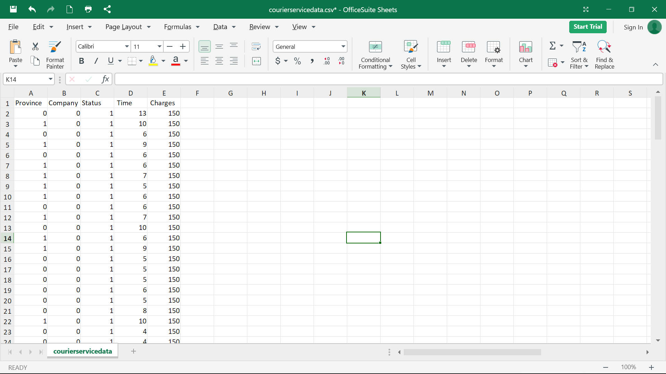

Fig:1

* In Province, 0 denotes Sindh and 1 denotes Punjab.
* In Company, 0 denotes Bluex and 1 denotes DHL.
* Status, 1 denotes success delivery and 0 denotes Package returned due to some issue.

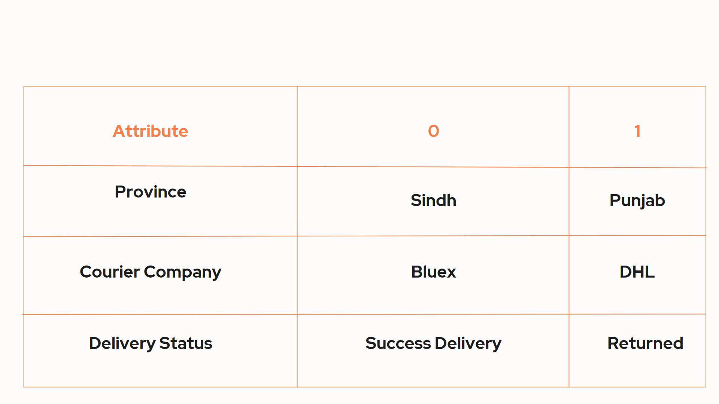

Fig 2: Attribute and description of dataset used for research.

## Tool Used - Jupyter

In a range of computer languages, Jupyter develops open-source software, open standards, and services for interactive computing.

Jupyter Notebook is primarily a web-based programme for creating and sharing documents that include code, visualisations, and text. It is utilised in data science, statistical modelling, machine learning, and a variety of other applications.

C.1. Steps for Installing Jupyter

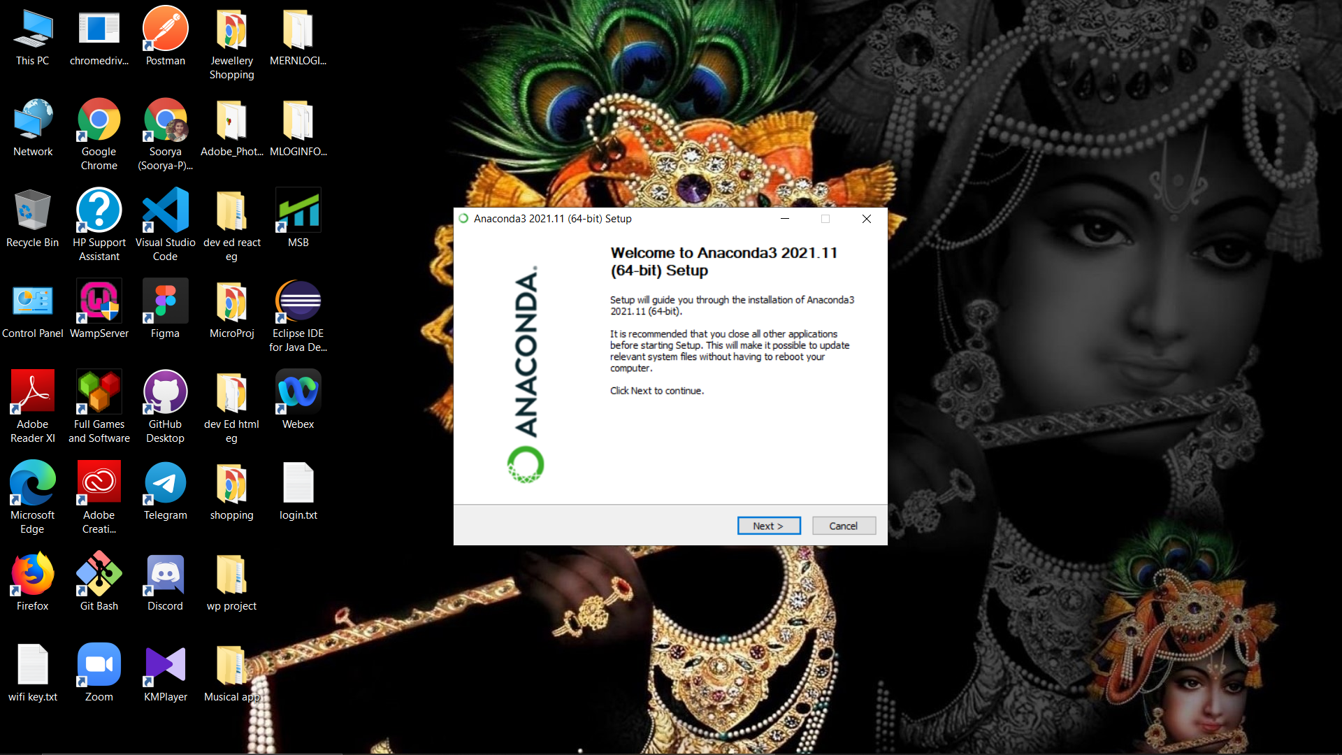

Fig:3.1



Fig:3.2



Fig:3.3

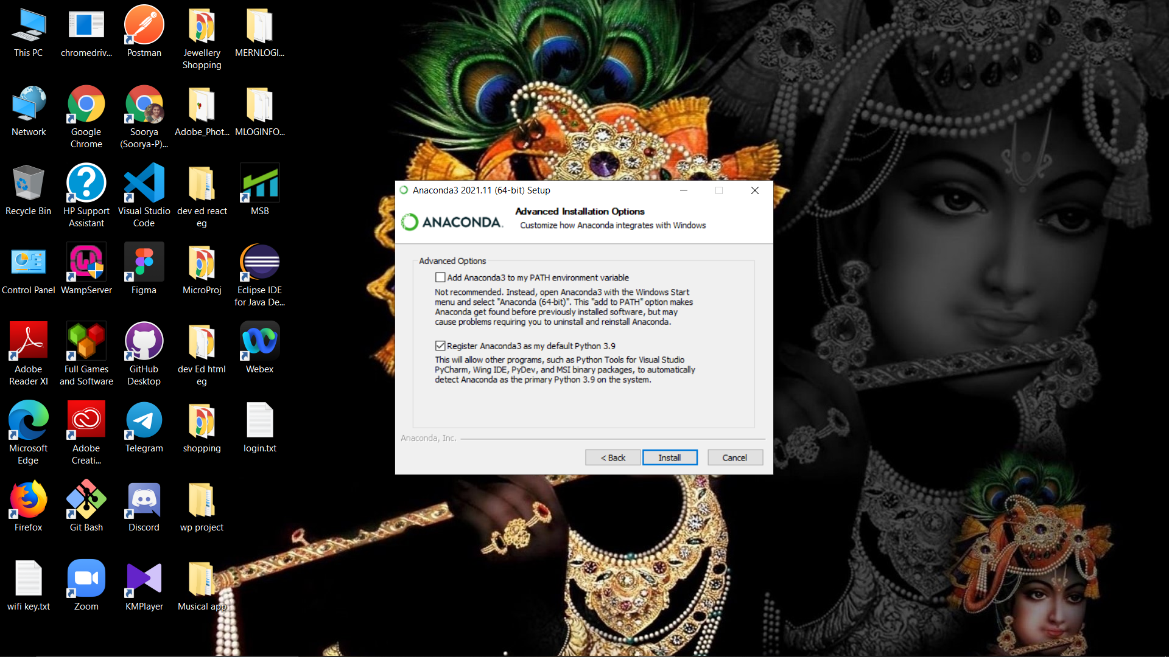

Fig:3.4



Fig:3.5



Fig:3.6

# DATA MINING OVERVIEW

From marketing and promotion for commodities, functions, and products to artificial intelligence research, medical sciences, crime investigations, and high-level government intelligence, data mining has a wide range of uses. Data mining technologies have been developed over decades due to their extensive use and the complexity involved in developing information mining applications. Each instrument has its own set of advantages and disadvantages. A set of data mining tools has been produced by a research community and data analysis hobbyists and is freely available under one of the current open-source licenses. An open-source development model indicates that the tool is the result of a community effort, not necessarily backed by a single organization, but rather the result of contributions from a global and informal development team.

This method of improvements allows for the integration of numerous experiences. Data boring provides a variety of excavation strategies for extracting data from db. Data mining tools predict the outcome and behaviors, enabling firms to make educated, proactive decisions. Data mining algorithm creation and application necessitates the usage of extremely strong software tools. The selection of the most appropriate tool becomes increasingly difficult as the number of available tools grows.

# IV.RESULTS

The Research paper is implemented using the Jupyter Tool to obtain the result.

* If Jupyter is installed in the system then first, navigate to the Jupyter Notebook interface home page.
* Then, select the file you want to upload by clicking the Upload button.
* Finally click the upload button

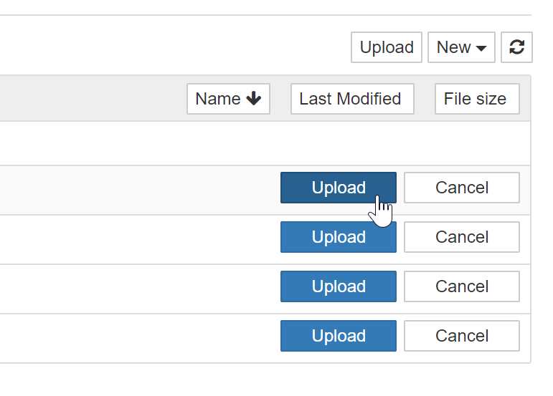

Fig:4.1

# 

## Import necessary Libraries

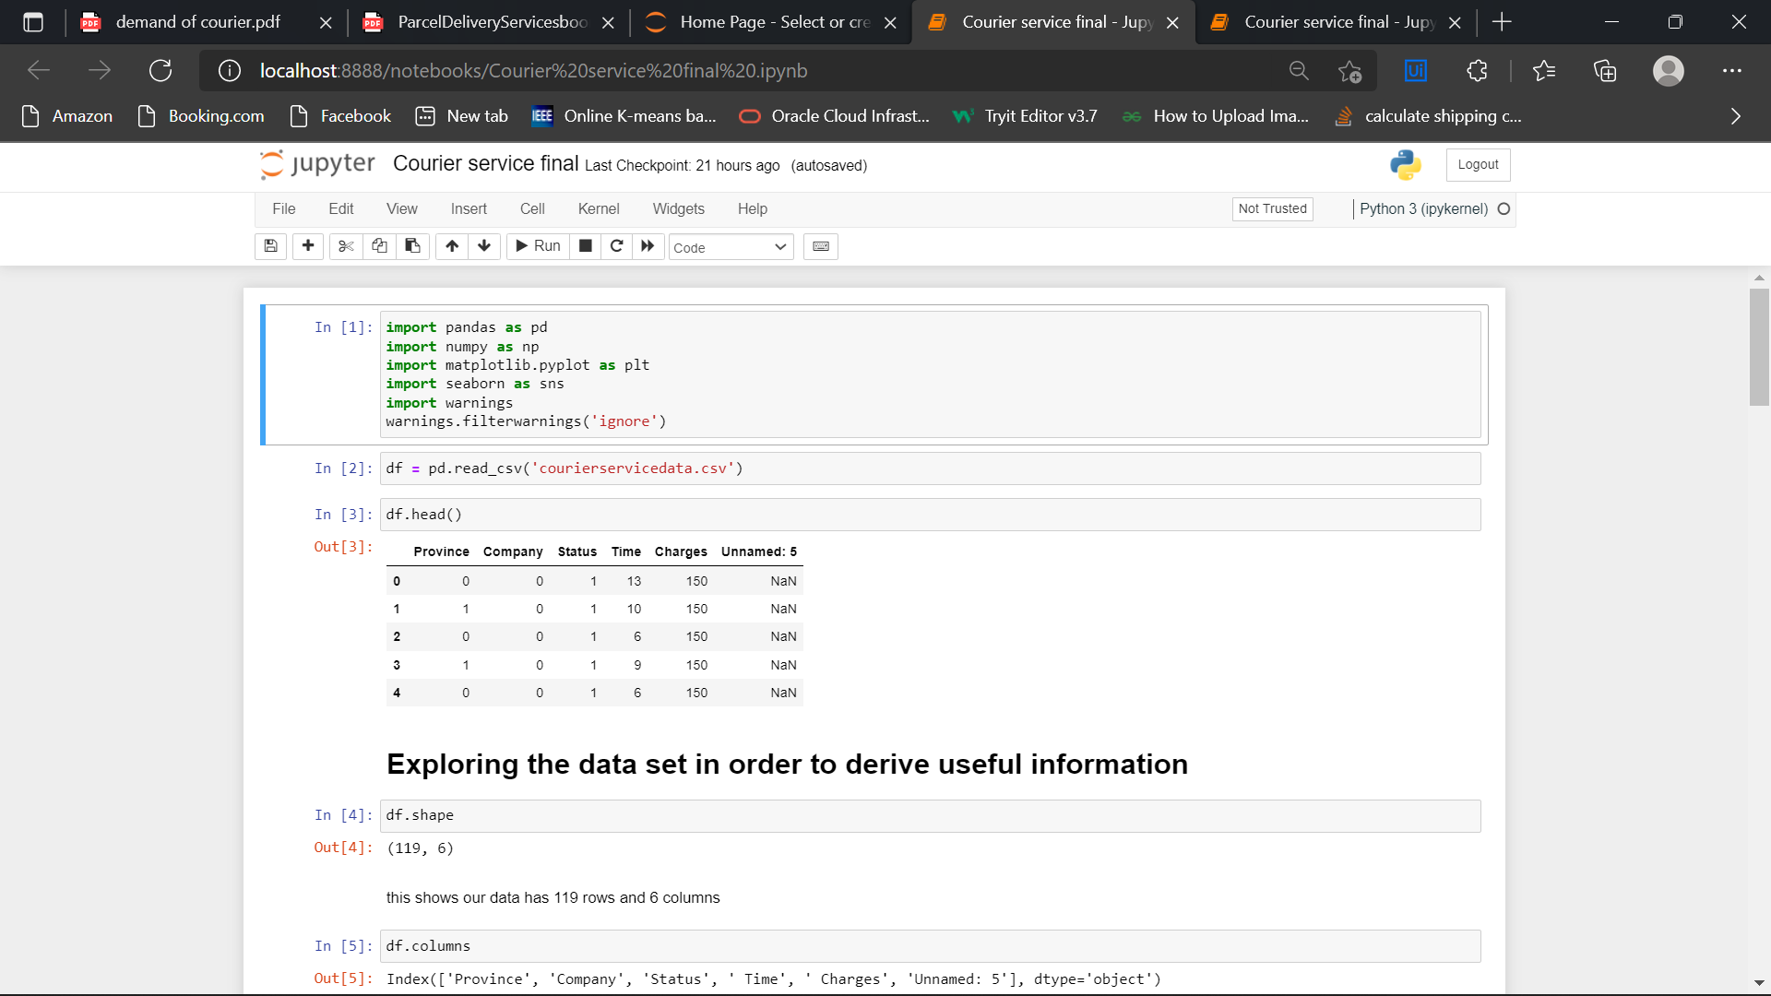

Fig:4.2

## Analyzing the data collection to extract useful information

Fig:4.3

## Finding the correlation among the attributes

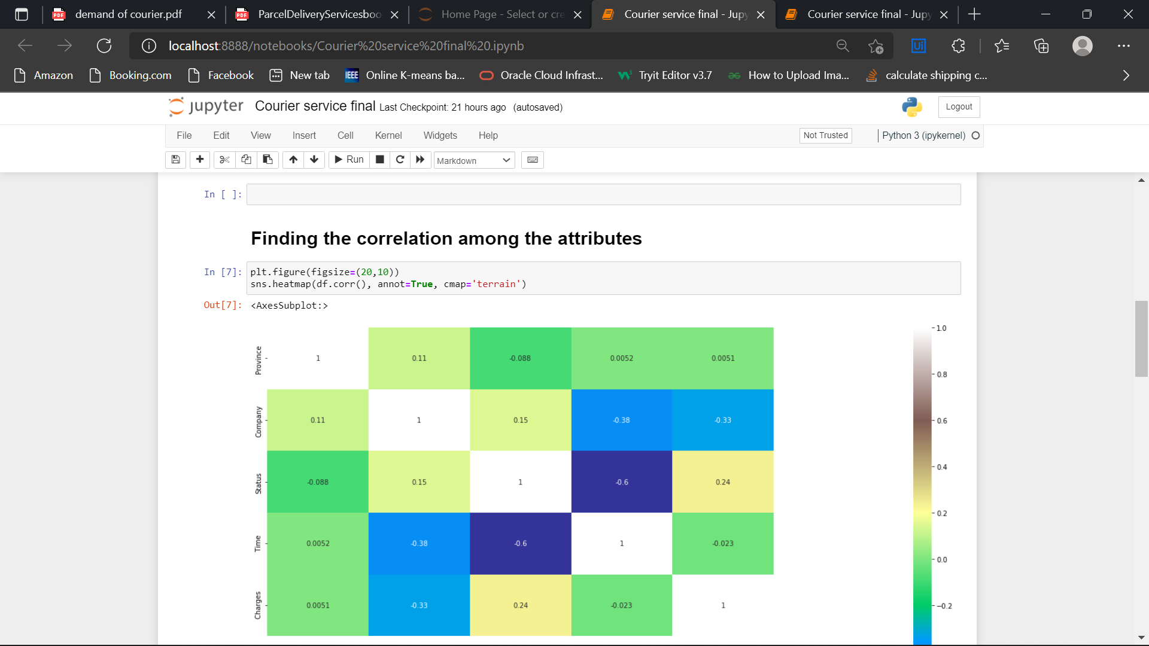

Fig:4.4

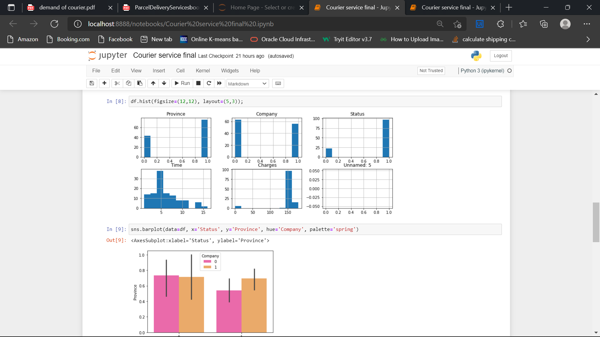

Fig:4.5

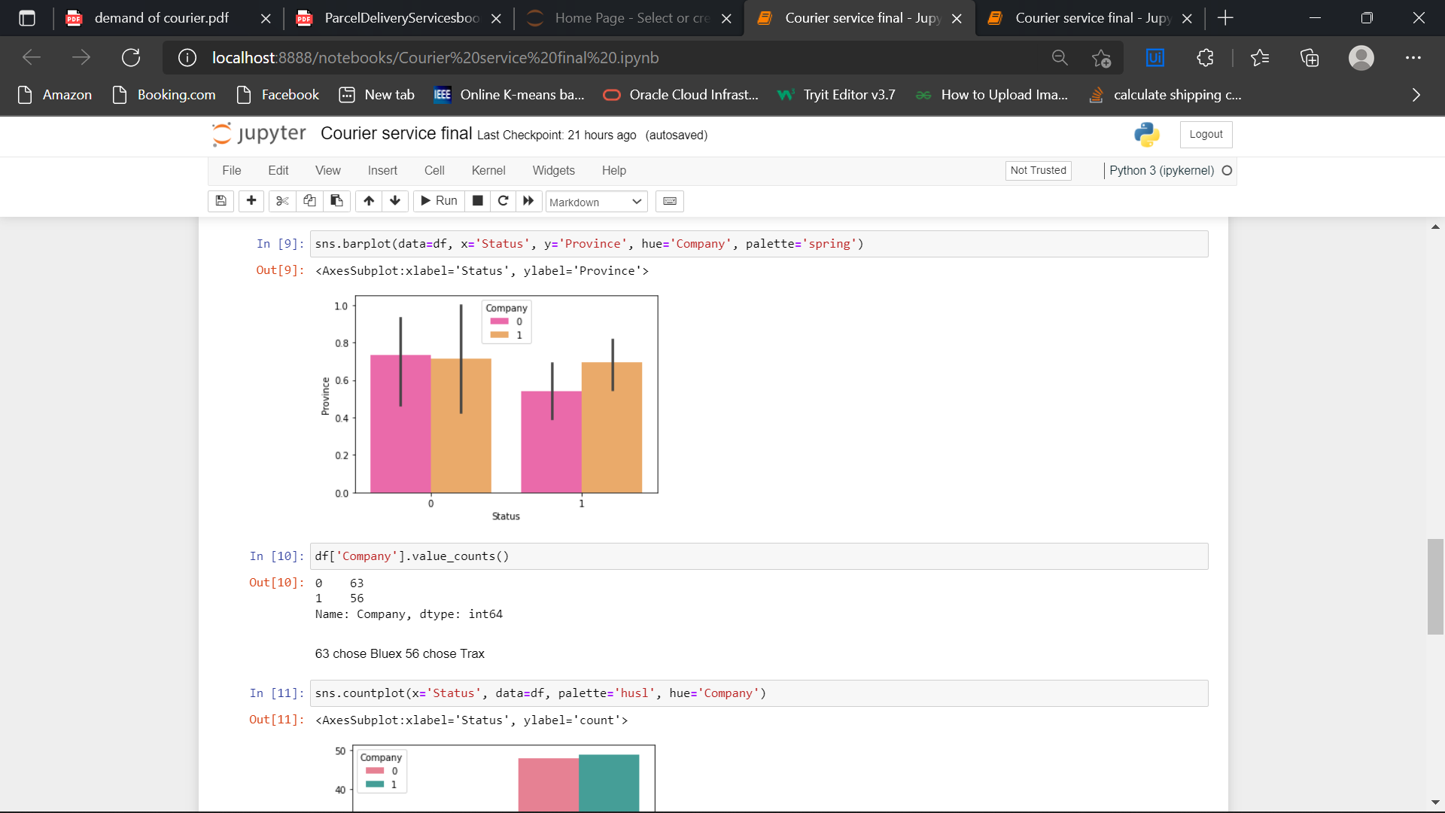

Fig:4.6

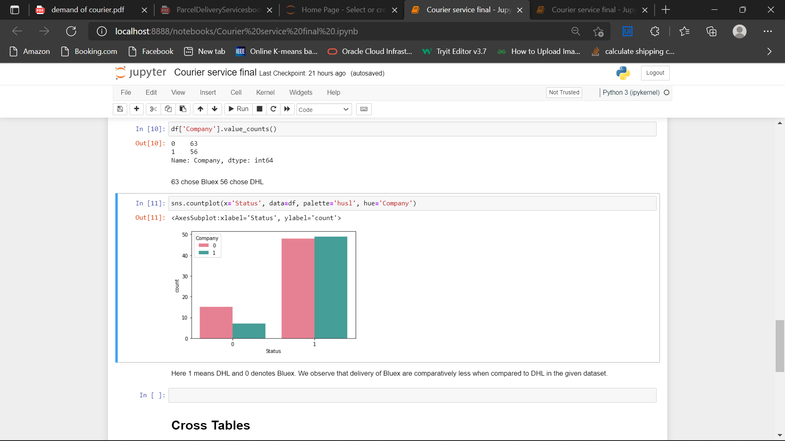

Fig:4.7

## Cross Tables

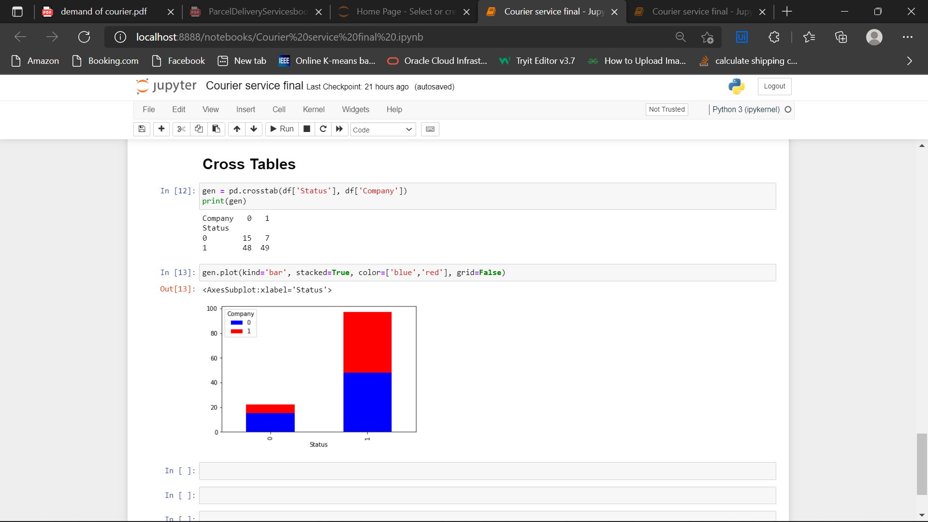

# V.CONCLUSION

The figure given above is plotted against Delivery Status and Courier service Provider. Status 1 denotes that the delivery is a Success and 0 denotes that the parcel is Returned. Company 1 denotes DHL and 0 denotes Bluex. From the figure it is clear that Bluex Courier Service provider has more successful courier delivery than that of DHL in Punjab and Sindh. So the study concluded that the Covid-19 Pandemic in India, which indeed led to a complete lockdown made the people of Sindh and Punjab to prefer Bluex Courier Service than that of DHL.

# REFERENCE

1. Dablanc, L., Morganti, E., Arvidsson, N., Woxenius, J., Browne, M., Saidi, N., 2017. The rise of on-demand “instant deliveries” in European cities. Supply Chain Forum: Int J, 1-15
2. Falzon, N., & Bugeja, T. (2020, April 20). The Covid-19 Economy - couriers, deliveries and legal issues. Retrieved July 30, 2020,
3. https://www.lexology.com/library/detail.aspx?g=b8a8716a-ecbc4534-802a-2d84366e65eb
4. Courier Service Philippines. (n.d.). Retrieved July 30, 2020, from <https://airspeed.ph/courier-service-philippines/>
5. Charm, N. (2020, July 20). Philippines' COVID-19 pandemic response highlights. Retrieved July 30, 2020, from https://www.bworldonline.com/philippines-covid-19-pandemicresponse-highlights.

Fig:4.8